

Annual Membership Celebration
Now Accepting Nominations for the Chamber’s Annual Meeting Awards
About the Awards
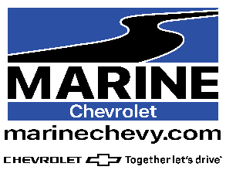
Jacksonville•Onslow Woman of the Year
This award is presented to a female who has demonstrated excellence in her profession and has devoted time and energy to the community. This award is sponsored by Marine Chevrolet.


Jacksonville•Onslow Golden Eagle Man of the Year
This award is presented to a male who has demonstrated excellence in his profession and has devoted time and energy to the community. This award is sponsored by Sanders Ford.

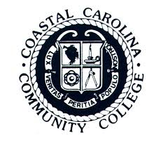
Jacksonville Onslow Civic Honoree of the Year
This Award recognizes an adult lifetime of service and exemplary contribution toward the betterment of our community.

2026 Nomination Form
Please check the award you are choosing for the honoree.

_______ Jacksonville•Onslow Woman of the Year
______ Jacksonville•Onslow Golden Eagle Man of the Year
_______Jacksonville Onslow Civic Honoree of the Year
Nominee:
Mrs. / Ms. /Mr.:_______________________________________________________________
Company: ____________________________________________________________________
Business Address: ____________________________________________________________
City: _______________________ State: _______________ Zip/Postal Code:___________
Title or Position: ______________________________________________________________
Nominator:
Mrs. / Ms. /Mr.:_______________________________________________________________
Company: ____________________________________________________________________
Work Telephone :(____) ________________________________________________________
Cell Phone :(____) _____________________________________________________________
Please provide the information below.

1. Community Service:
Please include local, county and state level participation.

2. Chamber of Commerce Involvement:
Local community work, special assignments, seminar activity, involvement via sponsorship, time and/or service donated.

3. Business Accomplishments
Please indicate special recognition or special projects with nominee’s business/organization. Include business-related affiliations, professional associations, directorships, trusteeships, or other designations and the dates of services associated with each.

4. Other Memberships, Achievements & Awards
Indicate memberships, achievements and awards not already covered in previous categories.

THE DEADLINE FOR THIS NOMINATION FORM IS May 31, 2026 at 12:00
Email, Mail or fax completed nomination form and supporting materials to:
Jacksonville•Onslow Chamber of Commerce, 1099 Gum Branch Road
Jacksonville, NC 28540
Attn: Selection Committee
Fax: (910) 347-4705
Email: president@jacksonvilleonline.org

